ILM-France: ssh
10.40.54.118: 22
User:password: root/toor

vi /root/enb/config/enb.cfg
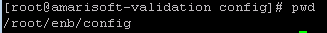

[root@amarisoft-validation config]# vi enb.cfg
Không dùng bàn phím số để chỉnh
Khi chinh sua minh dùng lenh ESC : wq! De save
Còn chỉnh sai thì dùng ESC : q! để thoát
[root@amarisoft-validation config]# service lte restart

http://niviuk.free.fr/lte_band.php : trang web xem band

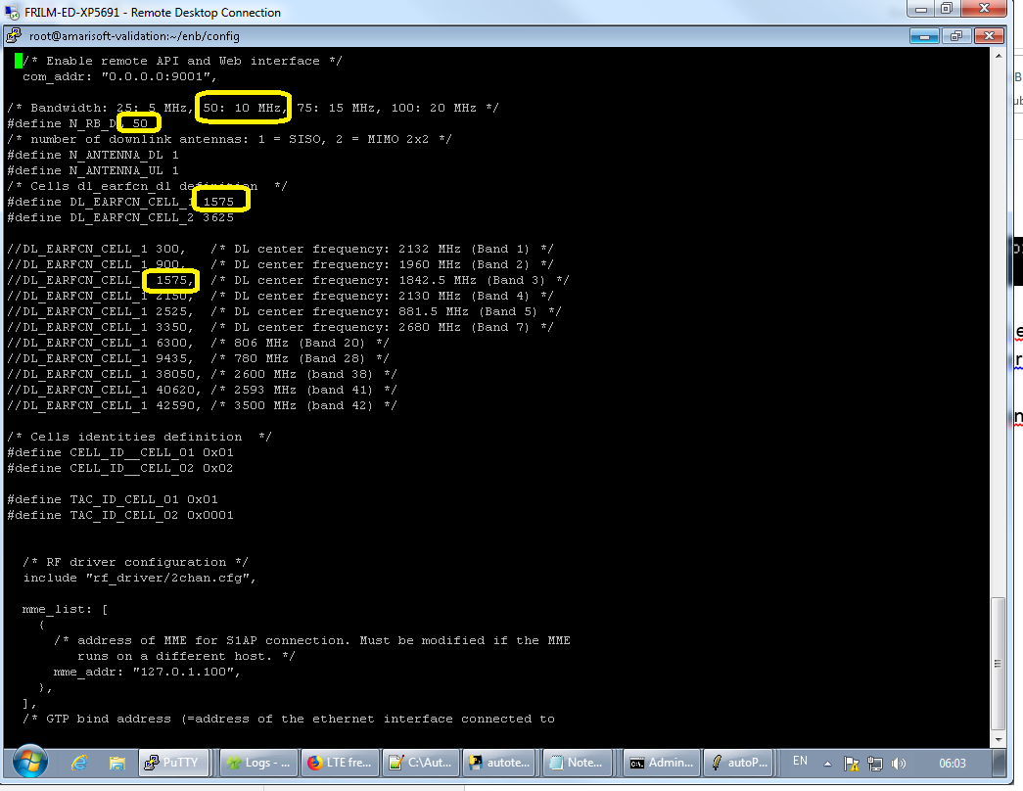

Change MNC/MCC code, change o 2 file enb.cfg va mme.cfg : change so giua
service lte restart
[root@amarisoft-validation ~]# vi enb/config/enb.cfg
[root@amarisoft-validation ~]# vi mme/config/mme.cfg

AT+KBNDCFG=0,1
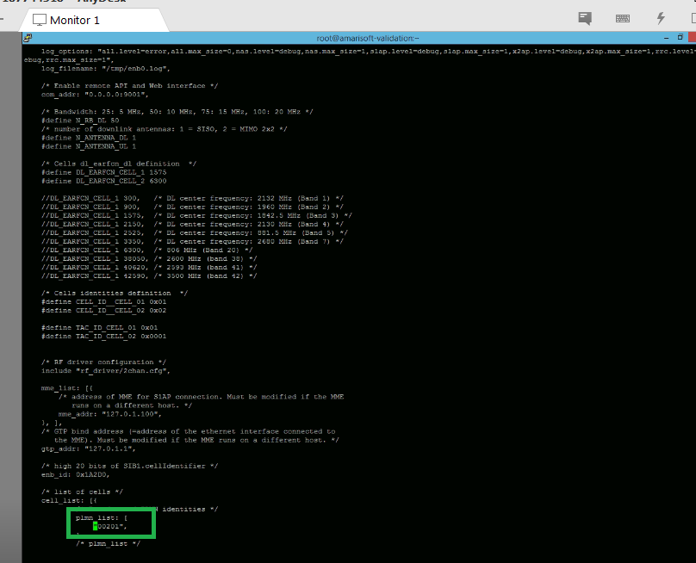

A_HL_Common_UC_0030
vi enb/config/enb.cfg
tac: TAC_ID_CELL_01,
#define TAC_ID_CELL_01 0x01
#define TAC_ID_CELL_02 0x0101

#define TAC_ID_CELL_01 0x01 => sua thanh #define TAC_ID_CELL_01 0x03
Thi
09:07:39.288 on 25-Oct-2018> +CEREG: 1,"0003","01A2D001",7
9:07:39.288 on 25-Oct-2018> AT+KCELL=0
09:08:52.108 on 25-Oct-2018>
09:08:53.820 on 25-Oct-2018> +KCELL: 0
09:08:53.820 on 25-Oct-2018> +KCELL: 0
09:08:53.820 on 25-Oct-2018> +KCELL: 2,5,00f110,1a2d001,,3,63,34,,6,,,63,34

TrackingAreacode

